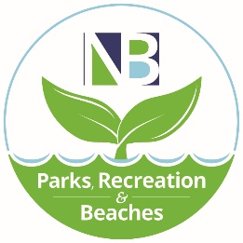
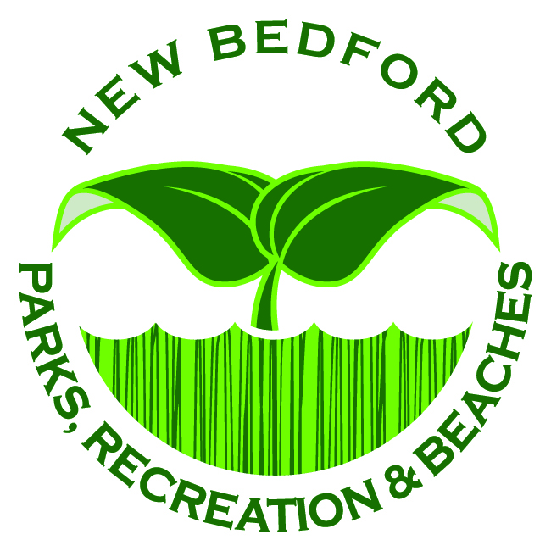
CITY OF NEW BEDFORD
Parks, Recreation & Beaches
Jonathan F. Mitchell, Mayor
________________________________________________________________________________________
Facility Rental Application

Name of Applicant or Organization: ____________________________________________________
Address: ______________________________________________________________________________
City: _____________________________________________________State:________Zip:____________
Home Phone: ________________________________Work/Cell Phone: ________________________
Email: ___________________________________________ Renter Date of Birth: __________________

Program/Activity with description(attach additional sheets if needed): ______________________________________________________________________________________________________________________________________________________________________________________________________________________________________________________________________________________________________

Name of Person Responsible at this Event: ____________________________Phone:______________________

Facility Information
Andrea McCoy Rec Center (visit: www.NBPRB.com or scan QR Code for photos/descriptions of rooms)

___ Arts & Crafts room Date: ______________________________
___ Computer Lab Set up Time: ____________________________
___ Gymnasium Event Start Time: ______________________
Kitchenette Event End Time: ________________________
___ Multi-purpose Room Break Down End Time: ________________________
___ Performance Stage Approximate Number in Attendance: ____________
**All rentals must be booked 30-days in advance. Rentals may require a certificate of insurance, CORI Verification, a custodian, and a police detail. You may be required to file a SPECIAL EVENT APPLICATION as well with this rental. **

Special Event Permit Application has been filed with the City of New Bedford Department of Public Infrastructure
___YES ___NO

Alcohol
Requests for alcohol must be approved by the
Parks Recreation & Beaches Department and the New Bedford Licensing Board
(Anyone who is found to have alcohol at an event without approval may be
deemed ineligible from any future rental of a city facility)
Will there be any alcoholic beverages served at your event? YES NO

If the service of alcohol is being requested, the applicant must contact the Office of the Licensing Board immediately, for approval of a Section 14 Special One-Day License (s).
Licensing Board Staff can be reached at (508) 979 - 1457

Facility Use Policies
- No alcoholic beverages shall be served, sold, advertised, or exhibited in the facility without the express written permission of the Park Board, the Department and the New Bedford Licensing Board.
- Nothing shall be advertised for, sold from, admission charge or fundraising, or exhibited in this Facility without the express written permission of the Park Board and the Department.
- The Facility’s tables and chairs may be repositioned but must be returned to their original set up prior to leaving. Balloons are not allowed. Cooking is not allowed at the Buttonwood facility and Fort Taber Community Center, but food may be warmed. Renter is responsible for the cleaning of all kitchen facilities.
- The use of any inflatable toy such as bounce house or ball pit will not be allowed indoors at any time. Any outdoor use must be approved by the Park Board 90 days prior to the rental.
- The designated “Person Responsible at this event” at the facility shall be responsible to maintain order among the attendees at this event; remove all trash from the Facility at the conclusion of the event, and; assure that the Facility’s buildings and grounds are clean and restored to arrival condition prior to leaving.
- The applicant individual and/or organization granted approval to use the Facility assumes responsibility for any accidents resulting in physical harm to persons or property during said use, and herewith releases and holds harmless the City of New Bedford, its employees, and agents from such liability. City of New Bedford may request insurance or bond.
- No Facility reservation will be held without payment. Reservations are first come first served basis. Payment must be paid in 60 days before event. In some cases, a 3 hour deposit can be given to hold a date for events 180 days or more in advance. Please contact the office for more information.
- All cancellations on behalf of the renter should be made no later than 48 hours (2 business days) prior to the rental. If rental is cancelled less than 48 hours we cannot guarantee a refund to be made.
- A processing fee of $50 will be held on any cancelations requesting a refund. Refund can take up to 4 to 8 weeks. City of New Bedford has the right invoice renter for any additional time.
**I have received and read the attached rules regarding facility use of a city owned building.

________________________________________ ____________
Signature Date
Waiver
In consideration of this application and/or the right to participate in this agreement, I or my designated representative, release the City of New Bedford, its employees, agents, representatives, and other persons or organizations for whose conduct the City may be responsible from any and all liability, loss damage, costs, claims and/or causes of action, including but not limited to all bodily injury claims and property damage resulting from or arising out of the use of premises, facilities, or equipment of the City of New Bedford, and/or caused in any way by the City of New Bedford, its employees, agents, representatives, and other persons or organizations for whose conduct the City may be responsible. I have been informed of the policies, including the refund policy, if applicable. I fully understand this waiver and voluntarily accept its terms. I certify, under the penalties of law, this information is correct.

Applicant Signature: ___________________________________________ Date: _____________________
Applicant Printed Name: __________________________________________
Rental Application Checklist
- Payment for facility rental
- Please make checks payable to City of New Bedford, please include in the “memo” section date of event and name of facility
- Bounced checks/credit card transaction will be charged $25 or 1% over $2,500.00.

PLEASE KEEP THE FOLLOWING PAGE FOR YOUR RECORDS
Liquor Policy
All events that are requesting alcohol must go before the Office of the Licensing Board, which is located in City Hall, Room 206. All events with liquor requests, being single or multiple days and/or personal or private event must go through a step-by-step process that is requested and cleared through the Office of the Licensing Board. LIQUOR Permit must be displayed at the event. PRB, Park Board, or the Licensing Board may require a police detail for events serving liquor.

Catering and Cooking Regulations
There is no cooking at any of the Community Centers. Kitchenettes (if operable) are allowed for use but solely for warming food and storage. The City of New Bedford and the facility rentals do not have any bussing of tables or day of event staff other than a custodian who is the key holder the day of the event rental. The custodian on duty is solely responsible for the building supervision.

Cleaning Responsibilities
The renter is responsible for the restoring of the building to its prior original condition. No party will leave without the cleaning of the building both inside and outside. Tables and chairs must be returned to appropriate location which is directed by the custodian on duty. All decorations and accessories must be removed and taken after event. Trash must be put in appropriate bags and put into dumpster which is located outside of the building. Recycling is mandated by the City of New Bedford. Please use recycling containers provided. This must be done during your rental time. Failure to meet the standards of cleanliness required may forfeit the entire or part of the security deposit.

Parking
Parking during non-peak times is provided based on the availability in the public parking lots. Each Community Center in the city has a parking lot. During non-peak season, parking at Fort Taber Community Center parking lot is included with the rental. During peak season, Fort Taber Park is paid parking either by seasonal or daily pass. If the renter chooses to do so, an additional fee for $20/hr may be added to the rental rate to ensure free parking for the event and its attendees in a lot designated by the Department for event parking. Off season discounts are available as well. Parking at the venue may run into challenges depending on the weekend/day of rental when other events located in a close proximity. Please consult with the Parks Recreation & Beaches office.

General Information
Every rental will be provided one employee from the City of New Bedford. This employee will adhere to the times that have been permitted and instructed by his/her superiors. The employee on duty is not responsible for the flow or running of the event/rental. The employee on duty is in charge of the space and reserves the right to prohibit requests/actions based on his or her judgment and knowledge of the rules and regulations of the City of New Bedford and the Department of Parks Recreation & Beaches and any other department that is involved. The employee at any point can ask you to leave if you did not follow the rental agreement. Event organizers may need to file a special events application with Department of Public Infrastructure as well, please contact PRB with any questions. PLEASE HAVE YOUR FACILITY USE PERMIT ON SITE WITH YOU THE DAY OF YOUR RENTAL. Show this permit to the employee when entering the building.

Decorating
Decorations must be placed without any materials that could harm the building either interior or exterior. Absolutely no open flames on any city premises, including fireworks, unless approved by the Fire Department and Parks Recreation & Beaches departments. Decorating and set-up time is NOT included in the rental. The renter must pay for whatever time is needed to set-up and prepare for their event. Also, they will take into consideration for break down time as well. The use of any infallible toy such as bounce house or ball pit will not be allowed indoors at any time. Any outdoor use must be approved by the Park Board 90 days prior to the rental. Please contact the office for additional information. No helium balloons are allowed in parks or park buildings.
Outside Service Vendors
The Department of Parks Recreation & Beaches must have contact information for any outside vendors that will be involved in the event. All vendors must fill out an “Outside Service Provider” form and agree with the rules and regulations set by the City of New Bedford and the department. These vendors should be made aware of the times reserved for set up and take down and the park regulations as well. Please use 1 form per vendor. Failure to comply with any or all these rules could result in the renter’s loss of the security deposit or bond. Additional copies can be emailed and are available online and at the Park Department. City of New Bedford may require proof of insurance from these vendors as well.

Payment & Security Deposit
Payment is due in full for a minimum of 3 hours for your event. Times can be changed up to 30 Days before the event. Payment must be made in the form of check, money order, or credit card. Any credit transaction will be charged a convenience fee and any returned checks are subjected to a $25.00 fee or 1% of the check amount if the check is over $2500.00. Events may be required to obtain a Bond or property damage insurance. If the Park Board requires a bond, they will determine the amount for bond. Bonds do not exceed $5000.00 and need to be received in the office no less than 30 days prior to the rental. All checks should be made payable to the City of New Bedford.

Event Shut Down and Clean Up
Renters are responsible for the prompt departure of their guests. If guests, vendors, or anyone affiliated with the party remain in the building past the event’s scheduled time of termination, the renter will be invoiced for the additional time. If the building is not cleaned or trash is left behind, you will not be allowed to rent a park facility in the future.

Closings Due to Outside Circumstances
The City of New Bedford Parks Recreation and Beaches Department reserves the right to cancel, postpone, or suspend any event at any time for health and safety reasons. In addition, if weather conditions do not permit the use of facilities, PRB may cancel or postpone any event at any time. No economic consequences shall impact the City of New Bedford due to such cancellations. PRB staff will work with the rental in advance to limit this occurrence and help with securing a new date if feasible based on availability.

Facility Rental Fees
Rate does not include additional set-up and breakdown time. You must pay for all time that is needed in the building. Peak period begins the Friday of Memorial Day weekend and ends the Monday of Labor Day weekend. All rentals are 3-hour minimums.
Non-Peak Period
Facility | Resident  (personal use) | Non-Resident (personal use) | Not for Profit | For Profit
Fort Taber Comm. Center | $75/hr | $95/hr | $100/hr | $125/hr
Brooklawn Community Center | $65/hr | $95/hr | $95/hr | $115/hr
Buttonwood Community Center | $65/hr | $95/hr | $95/hr | $115/hr
All Other  Facilities | $65/hr | $95/hr | $95/hr | $115/hr

Peak Period

Facility | Resident  (personal use) | Non-Resident (personal use) | Not for Profit | For Profit
Fort Taber Comm. Center | $100/hr | $110/hr | $115/hr | $150/hr
Brooklawn Community Center | $75/hr | $95/hr | $95/hr | $125/hr
Buttonwood Community Center | $75/hr | $95/hr | $95/hr | $125/hr
All Other  Facilities | $75/hr | $95/hr | $95/hr | $125/hr

CITY OF NEW BEDFORD
PARK, RECREATION and BEACHES
RULES & REGULATIONS

This beautiful public space is yours to enjoy for relaxation and recreation. Please respect others and keep our park clean. Parks and playgrounds are open dawn to dusk.
Prohibited activities:
- Use of or possession of alcohol or illegal drugs
- Use of vulgar or threatening language
- Operation of unauthorized vehicles on park property
- Parking or Driving on the lawn.
- Bicycles on the lawn
- Dumping or littering
- Vandalism of a tree, plant, or park structure
- Unleashed animals or any animal within 100 ft of a recreational area
- Fires, fireworks, or firearms of any kind
- Feeding birds or wildlife
- Use of metal detectors without a permit
- Golfing
- Smoking
- Performances, solicitations, or commercial activity without license from Parks, Recreation & Beaches
- Use of the park after it is closed without proper permission.
- Skateboarding except where indicated
- Sleeping
PLEASE ATTACH AN OUTSIDE SERVICE PROVIDER FORM TO THIS APPLICATION

If you have any additional question, please contact the office at (508)961-1623

CITY OF NEW BEDFORD
Parks, Recreation & Beaches
Jonathan F. Mitchell, Mayor
__________________________________________________________________________________________
Outside Vendor Form

Event Name: ____________________________________________ Event Date(s): ________________

Event Location: _________________________________________________________________

Business Name: __________________________________________________________________

Business Address: _________________________________________________________________
_________________________________________________________________

Vendor Contact Person: _____________________________________________________________

Vendor Phone Number: _____________________________________________________________

Vendor Type (please circle one)

Portable Restrooms Caterer Band Bar Service

Event Planner Photographer Tent Company DJ

Other _________________________________

I have read and understood the conditions governing the use of the facility and park rentals with the City of New Bedford and the Department of Parks Recreation & Beaches. My signature below acknowledges that I have read and understand the rules and expectations. Failure to comply with any or all of these rules could result in the Renter’s loss of their security deposit or bond.

__________________________________________
Printed Name of Signer

__________________________________________ ______________________
Vendor Authorized Signature Date

__________________________________________ ______________________
Event Organizer’s Signature Date

All outside service providers must fill out and submit an Outside Service Provider form upon contractual agreement with the renter and submit it to the Department of Parks Recreation & Beaches with the City of New Bedford. Vendor may also be required to show proof of insurance as well within 30 days of the event.

If you have any questions, please contact our office at (508) 961-3015
PLEASE FEEL FREE TO DUPLICATE THIS PAGE AS NEEDED!!!!

